

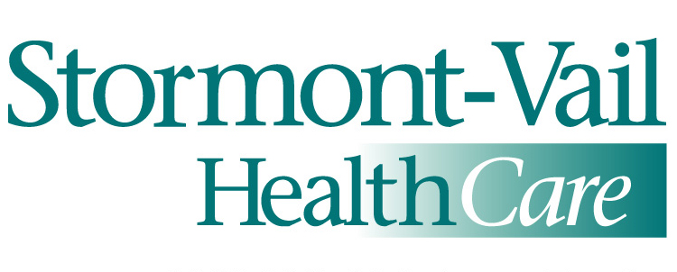

**Cause Sponsors**

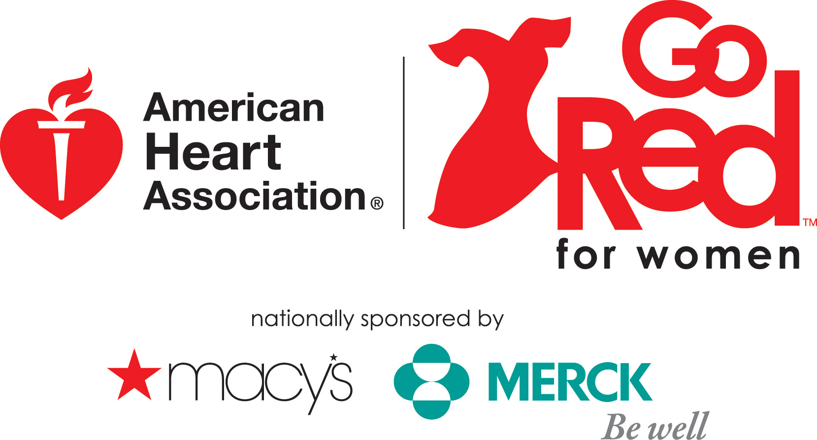

***What is Go Red for Women?***

Go Red for Women is the American Heart Association’s national campaign to increase awareness of heart disease — the leading cause of death for women — and to inspire women to take charge of their heart health.  The grassroots campaign has since grown into a vibrant national movement as more women, men, celebrities, healthcare professionals and politicians embrace and elevate the cause of women and heart disease. The yearlong campaign kicked off at the annual Go Red for Women Luncheon provides women of all generations with tips and information on healthy eating, exercise and risk factor reduction, such as smoking cessation, weight maintenance, blood pressure control and blood cholesterol management.

Go Red for Women has four components:

* Public education to increase awareness that heart disease is the No. 1 killer of women
* Educating healthcare professionals to assure that providers treat women according to guidelines
* Educating lawmakers about this issue
* Raising funds for women’s awareness, education and research programs

***What is Circle of Red?***

An elite group of women who have the influence and resources to significantly impact the community by providing a personal commitment to help find a cure for the number one killer of women.

***Who is a Circle of Red Member?***

An individual who can provide a personal commitment of **$250.00**

*(Commitment can be given over time and is separate from group sponsorship) You are allowed to make payments as long as payment is made in full prior to June 30, 2011. Membership runs from July 1, 2011 to June 30, 2012.*

***What Benefits my participation as a Circle of Red Member? 1***

* Help fund research grants needed to find a cure for Kansas number one killer of women
* Decrease the number of child deaths under the age of 15 (2,100 total annual deaths) due to congenital heart defects
* Increase continuing medical education (CME) programs to help physicians incorporate the AHA’s guidelines for preventing heart disease among women
* Increase AHA’s CPR in Schools programs, where an estimated 200,000 kids have been trained and many lives have been saved.
* Increase the awareness and prevention. “Of women who die, one in 29 die of breast cancer. About one out of every 2.4 women die of heart disease, stroke and other cardiovascular diseases.”

***Perks of a Circle of Red Member***

* + VIP Invitation (ticket) to attend Go Red for Women Luncheon (December 2, 2011). You will sit at the COR table during event.
  + Special Gift for joining
  + Profile and photo displayed in the Program of the Go Red for Women Luncheon Event
  + Recognition and Introduction from the Podium the day of the event
  + Year round opportunities to help bring awareness to women’s heart disease
  + Lunch and Learn Session with a Cardiologist to discuss women’s heart issues – Date TBD
  + “Nutrition – Building a Healthier You” Education class – Date TBD
  + Evening Social with other Circle of Red members – Date TBD
  + Tours of Stormont-Vail Health*Care* & St. Francis Health Center Cardiology Services – Date TBD

1 All funds are non-restricted